

CAMBRIDGE ‘A’ LEVEL PROGRAMME
AS TRIAL EXAMINATION AUGUST/SEPTEMBER 2007
(Jan & Mar 2007 Intake)

Thursday 6 September 20079.45 am – 10.45 am
PHYSICS 9702/02

PAPER 2 1 Hour

Candidates answer on the Question Paper
Data Booklet

This document consists of 12 printed pages.
© Taylor’s University College Subang Jaya 2007 [Turn over

READ THESE INSTRUCTIONS FIRST

Write your name, class and student number in the spaces at the top of this page.
Write in dark blue or black pen in the spaces provided on the Question Paper.
You may use a soft pencil for any diagrams, graphs or rough working.
Do not use staples, paper clips, highlighters, glue or correction fluid.

Answer all questions.
The number of marks is given in brackets [ ] at the end of each question or part question.
You may lose marks if you do not show your working or if you do not use appropriate units.
A Data Booklet is provided.
ClassStudent NumberName

For Examiner’s Use
1
2
3
4
5
6
7
8
Total

- (a) The kilogram, the metre and the second are base units. Name two other base units.
1. ……………………..
2. ……………………..
[2]
(b) The tension, T of a string and velocity, v of sound waves along it are related by the expression
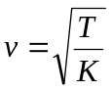
where K is a constant.

- Determine the base units of tension T.

base units:……………………………[2]

- Determine the units of K.

units:…………………………… [2]

- Using your answers to (ii) suggest what quantity may be represented by the symbol K.
.………………..………………..………………..………………..……………[1]

- (a) Define velocity
..……..………………..………………..………………..………………..…………[1]
(b) A house-martin has a mass of 120 g. When it returns to its nest, it is traveling horizontally at P with a speed of 13.0 m s⁻¹ and at a distance 7.5 m below its nest. It then glides upwards to the nest, as shown in Fig 2.1.

7.5 m
nest
Path of bird’s flight
P
Fig 2.1.
Neglecting any air resistance, calculate

- the kinetic energy of the house-martin at P.

kinetic energy:……………………………J
[1]
- the total gain in potential energy as it glides upwards to its nest.

gain in potential energy:……………………………J
[2]
- its kinetic energy as it reaches its nest.

kinetic energy:……………………………J
[2]

- its speed as it reaches its nest.

speed :…………………………… m s⁻¹
[2]

(c) State how air resistance affects, if at all, your answers in (ii) and (iv).
..……..………………..………………..………………..………………..…………….…
..……..………………..………………..………………..………………..……………[2]

- In order to display greeting cards, a student fixes a length of string between two nails and then suspends the cards from the string. Fig. 3.1 shows the string with one card of weight 0.60 N suspended by a light clip at the centre of the string. Angles are not drawn according to scale.
clip
40º
40º
nail
nail
string
string
0.60 N
Fig. 3.1

(a) (i) On Fig. 3.1, mark the forces on the clip due to the tension T in the string. [1]
(ii) Complete the vector triangle of Fig. 3.2 for the forces acting on the clip.
A scale of 1.0 cm representing 0.10 N has been used.

0.60 N

Fig. 3.2 [2]
(iii) Use your completed vector diagram to determine the magnitude of the tension in the string.

T :……………………………N
[1]

(b) The student decides to shorten the string. State, with a reason, whether the string, loaded with the same card, could have the same tension as before.

..……..………………..………………..………………..………………..…………….…
..……..………………..………………..………………..………………..…………….…
..……..………………..………………..………………..………………..……………[2]

- In a dynamics experiment, a trolley is accelerated from rest along a horizontal runway as shown in Fig. 4.1.

runway
Elastic cord
pull
trolley
Fig. 4.1
The accelerating force is provided by an elastic cord. One end of the cord is attached to the trolley and the other end is pulled so that the extension of the cord remains constant as the trolley moves along the runway.
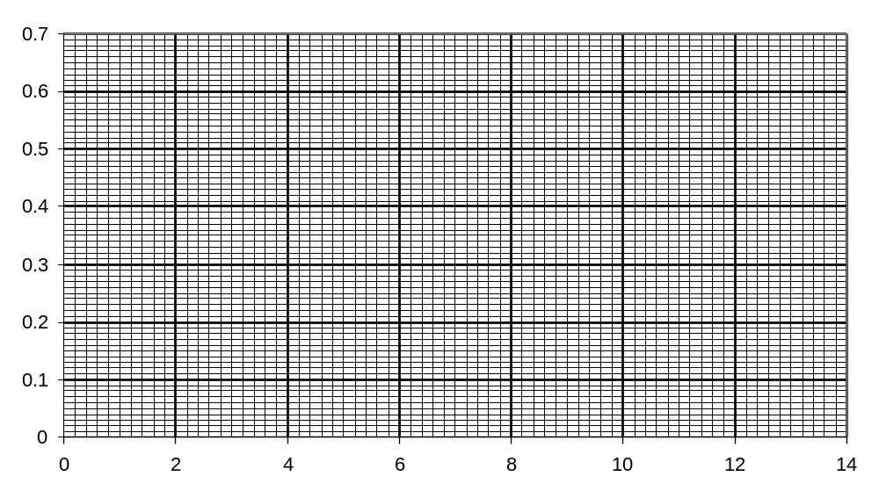
The acceleration a of the trolley varies with the extension x of the elastic cord as shown in Fig. 4.2.
a/ ms⁻²
x/ cm

Fig. 4.2.
The trolley experiences a constant frictional force when in motion
(a) Use Fig. 4.2 to
(i) determine the extension of the cord required to maintain constant speed of the trolley, giving a brief explanation for your answer.

extension :……………………………cm
[2]

(ii) find the extension to produce an acceleration of 0.60 ms⁻².

extension :……………………………cm
[1]

(b) (i) Calculate the force required, in the absence of friction, to cause the trolley of mass 800 g to have an acceleration of 0.60 ms⁻².

force :……………………………N
[2]

(ii) Using answers to (b)(i) and (a), determine the spring constant of the elastic cord. Assume that the cord obeys Hooke’s law.

Spring constant :……………………………Nm⁻¹
[2]
- A student sets up the apparatus illustrated in Fig. 5.1 in order to observe two-source interference fringes. A few parameters can be adjusted to get an observable interference pattern, as follows:
  - Slit width d
  - Slit spacing a
  - Distance X
  - Distance Y
  - Wavelength of light source λ

Slit width d
Slit spacing a
screen
Double slit
Light source
Distance Y
Distance X
Fig. 5.1

(a) State a suitable separation for the two slits in the double slit.
……………………………………………………………………………………..… [1]

(b) Explain how a light source of longer wavelength affects the interference pattern.
…..……………………………………………………………………………………..…
…..……………………………………………………………………………………..…
…..……………………………………………………………………………………..…
.……………………………………………………………………………………..… [3]

(c) State two parameters in each case, besides the wavelength of light source, that be adjusted to change
(i) the fringe spacing
…..……………………………………………………………………………………..…
.……………………………………………………………………………………..… [2]

(ii) the intensity of the bright fringes
…..……………………………………………………………………………………..…
………………………………………………………………………..……………..…[2]

- Fig. 6.1 shows four positions WXYZ in the region of a uniform horizontal electric field E of 30 Vm⁻¹. The lengths of WY and XZ are 5.0 cm and 7.0 cm respectively.
Fig. 6.1
X
Y
W
Z
E

(a) Determine the electric potential difference between points
(i) WY

p.d. across WY = …………………V

(ii) XZ

p.d. across XZ = …………………V
[4]

(b) Determine the electric force acting on an electron which is projected vertically downwards from X.

Force = …………………N [2]
(c) Describe the subsequent motion of the electron as mentioned in (b).
…..……………………………………………………………………………………..…
…..……………………………………………………………………………………..…
.……………………………………………………………………………………..… [2]

- A manufacturer of electric cookers makes the heater of the grill out of ten identical coils of wire. These coils are connected to one another and to the mains by way of two switches as shown in Fig. 7.1. The two switches are ganged together. This means that if one is off, both are off, if one is at X, both are at X, if one is at Y, both are at Y.

240 V
X
Y
X
Y
off
off
Ten heating coils
Left half of grill
Right half of grill
Fig. 7.1

(a) When both switches are at X,
(i) state if the left half of grill is connected in series or in parallel to the right half of grill
………………………………………………………………………………..… [1]

(ii) calculate the p.d. across each of the ten coils

p.d. = …………………V

(iii) calculate the resistance of each of the ten coils if each coil is to have a power output of 160 W

resistance = …………………Ω
[4]

(b) Describe what will happen to the grill if both switches are moved to Y. Suggest one advantage of this switching arrangement.
……………………………………………………………………………………………
……………………………………………………………………………………………
……………………………………………………………………………………………
……………………………………………………………………………………………
……………………………………………………………………………………… [3]

- (a) Explain the meaning of spontaneous nature of a radioactive decay.
…………………………………………………………………………………………[1]

(b) The thickness of a sheet of aluminium foil is to be monitored using β-radiation as illustrated in Fig. 8.1.

β-particles source
detector
Aluminium foil
rollers
Fig. 8.1

The separation of the rollers is controlled by the output from the detector with the intention of maintaining a constant foil thickness.

(i) Suggest a device for the detector
…………………………………………………………………………………[1]

(ii) Explain how the separation of the rollers should be adjusted if the output from the detector were to increase?
……………………………….……………………………………………………
…………………………………………………………………………………[2]

(iii) Suggest why a γ-radiation source would not be satisfactory for monitoring changes in thickness of the foil.
……………………………….……………………………………………………
……………………………….……………………………………………………
…………………………………………………………………………………[2]

